**Workshop: Cubicle – Part 3**

"*Cubicle*" is a place, where you can browse some of the most popular Rubik cubes in the world and add some new cubes that you have discovered.

If you missed the first two parts of this workshop, make sure you complete them before you continue because all parts of this workshop are related to each other.

**Main Task**

Now it's time to implement **user service** in your app, so people can **register**, **login** and **logout**. And each cube can be **edited** or **deleted**. Some of the functionality should **requires** **authentication** such as (create a cube, create accessory) and **authorization** (such as edit and delete). Also, all **routes** should be **protected**!

**Installing Dependencies**

You should install a few more packages which you will use. They are:

1. [**jsonwebtoken**](https://www.npmjs.com/package/jsonwebtoken) - allows you to decode, verify and generate JWT
2. [**bcrypt**](https://www.npmjs.com/package/bcrypt) - a library to help you hash passwords
3. [**cookie-parser**](https://www.npmjs.com/package/cookie-parser) - parse **cookie header** and populate **req.cookies** with an object keyed by the cookie names (if you choose to store the **jwt** as а **cookie**)

## Model

The User Model structure:

* **Id** - ObjectId
* **username** - string
* **password** - string (**hashed**) - Use **bcrypt** to **hash** and **compare** the password

Make sure, when you successfully create a new user into the database, you generate a **jsonwebtoken** and use it later for **authentication** and **authorization**.

Also, you have to add an additional property on **Cube** **Model,** which is **creatorId** (type: **String** and its **required**), so you can keep tracking every cube's creator.

## Routes Protection

Make sure the **anonymous** (guest) users **can't** **reach** the functionality which requires authentication, such as create a cube view. And **already logged in** users have generated and stored **jwt**, **can** see the correct navigation and **can't reach** the login and register form. If some of these scenarios is happen, make sure the current user is redirected to the home page.

### Authentication

**Guest** users can **see** and **access** the following urls**:**



* **Home page (Browse)**
* **About page**
* **Login page**
* **Register page**
* **Cube details page**

And **can't access** and **see** everyone else...

**Logged** in users can **see** and **access** the following urls:



* **Home page (Browse)**
* **About page**
* **Add cube**
* **Add accessory**
* **Logout**
* **Cube details page**
* **Cube accessories page**
* **Edit Cube page**
* **Delete Cube page**

### Authorization

Only **authorized** users should see the [**Edit**] and [**Delete**] buttons and if the **currently logged-in user is the creator of this cube**. Otherwise, they should be **hidden**.

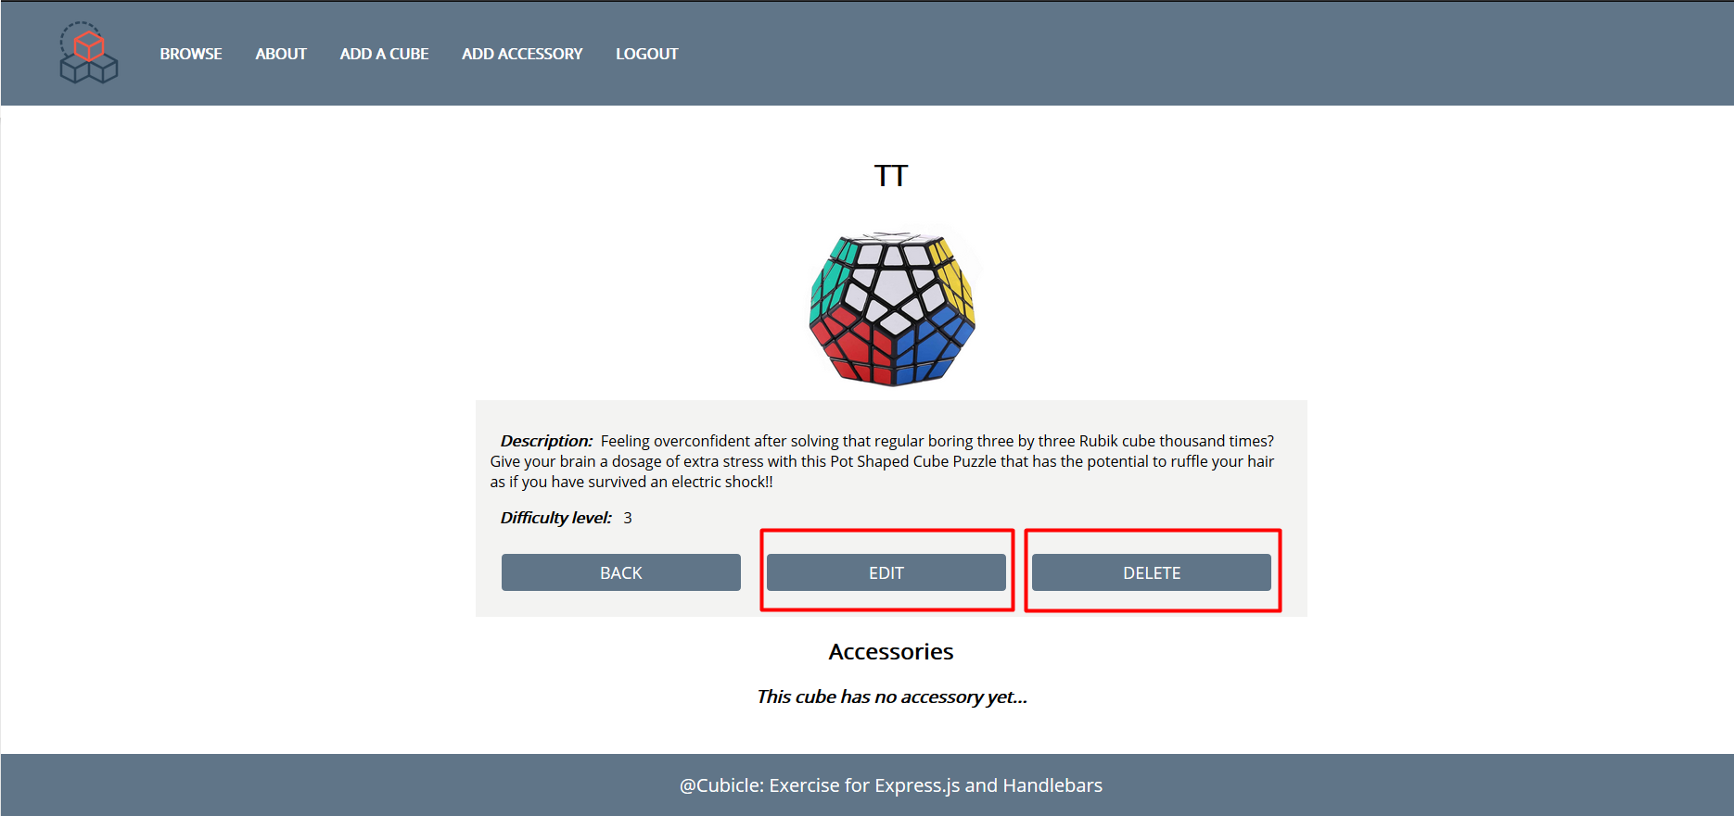

## Additional Pages

You should implement **4** new routes:

* **/login** - should render the login form
* **/register** - should render the register form
* **/edit** – should render the edit form
* **/delete** – should render the delete form

Make sure when you access /**edit** and /**delete** routes, they show the current cube information.

Use the provided [**RESOURCES**](http://svn.softuni.org/admin/svn/js-web/Sept-2019/JS-Back-End/05.%20JS-Back-End-Sessions-and-Authentication/05.%20Sessions-and-Authentication-Workshop-Resources.zip) to create the additional templates using Handlebars (Use **username: student**, **password: student** credentials to do that). Identify the dynamic parts and use appropriate syntax for interpolating and rendering the application context. Replace the old **CSS** file with the given one.

### Login Page

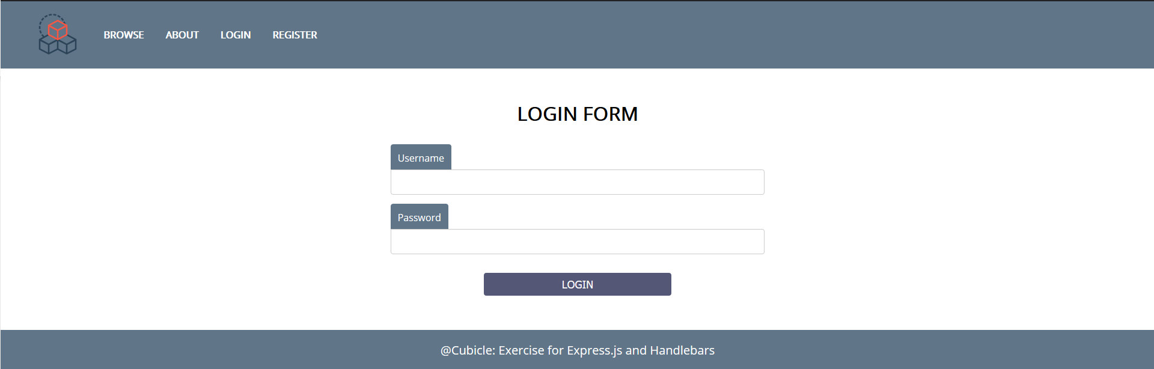

Register Page

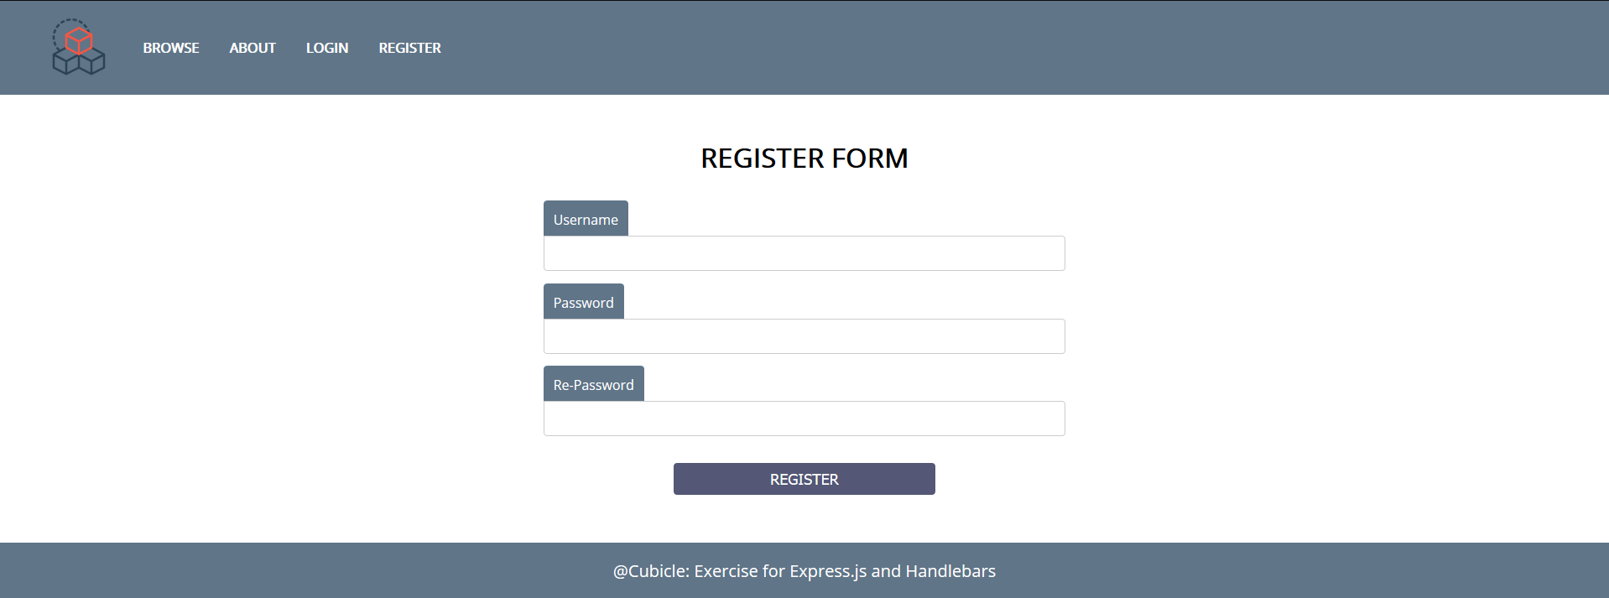

### Edit Cube Page

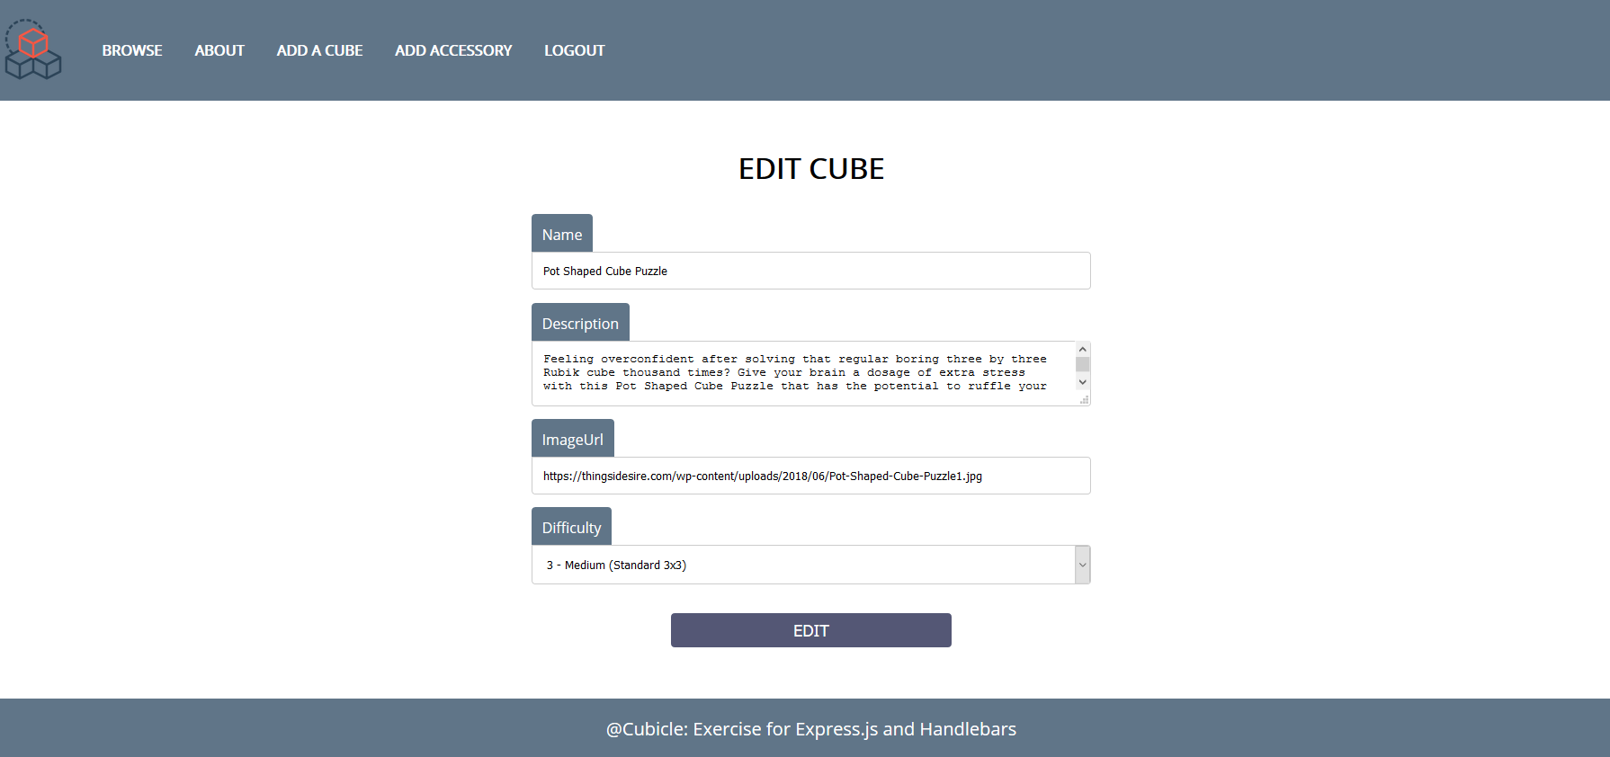

### Delete Cube Page

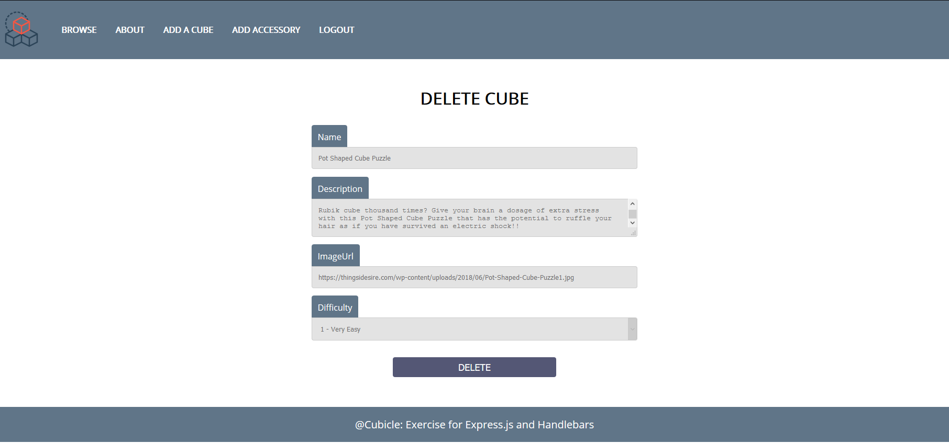

**Good Luck! 😊**